

Chicken and Sausage Cassoulet with Boulangère Potatoes (1, 11, 14)
(Chicken and Sausage Stew)
Roasted Vegetable Ratatouille VEGAN
Pates au Pistou (1)
(French Pesto Pasta)
Jacket Potato with Choice of Toppings
French Beans
Tarte Fine Aux Pommes (1)
(French Apple Tart)

THURSDAY 25 SEPTEMBER

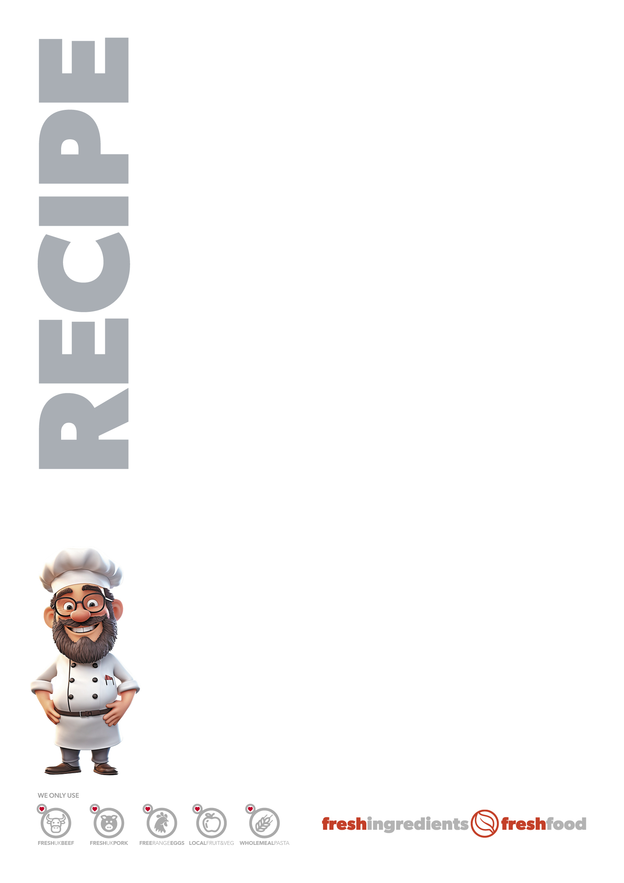
CHICKEN CASSOULET (MAKES 50 PORTIONS)
INGREDIENTS
• 2 kg of diced 50/50 chicken
• 40 Cumberland sausage
• ½ tin of baked beans
• 4 large onions
• 4 heaped spoons of garlic
• Chicken stock
• Oregano
METHOD
• Brown off sausages first.
• Fry off sliced onions,
• Then in a tin place chicken, cooked onions, garlic, seasoning, oregano and just
cover with chicken stock.
• Cover with foil and bake.
• When chicken is cooked, add beans and sliced sausages, stir through. Then
put bake back in oven to finish off.
RATATOUILLE (MAKES 50 PORTIONS)
INGREDIENTS
• 4 courgettes
• 2 aubergine
• 2 large onions
• ¼ kg mushroom
• 8 carrots
• 6 tomatoes
• Garlic puree
• 6 tbs tomato paste
• ½ tinned tomatoes
• Mixed herbs
• Seasoning
METHOD
• Chop and roast all veg/herbs, garlic, seasoning/tomato paste, tinned toms.
• Cover with foil until cooked through.
• Then remove foil if it needs thickening place uncovered in oven.
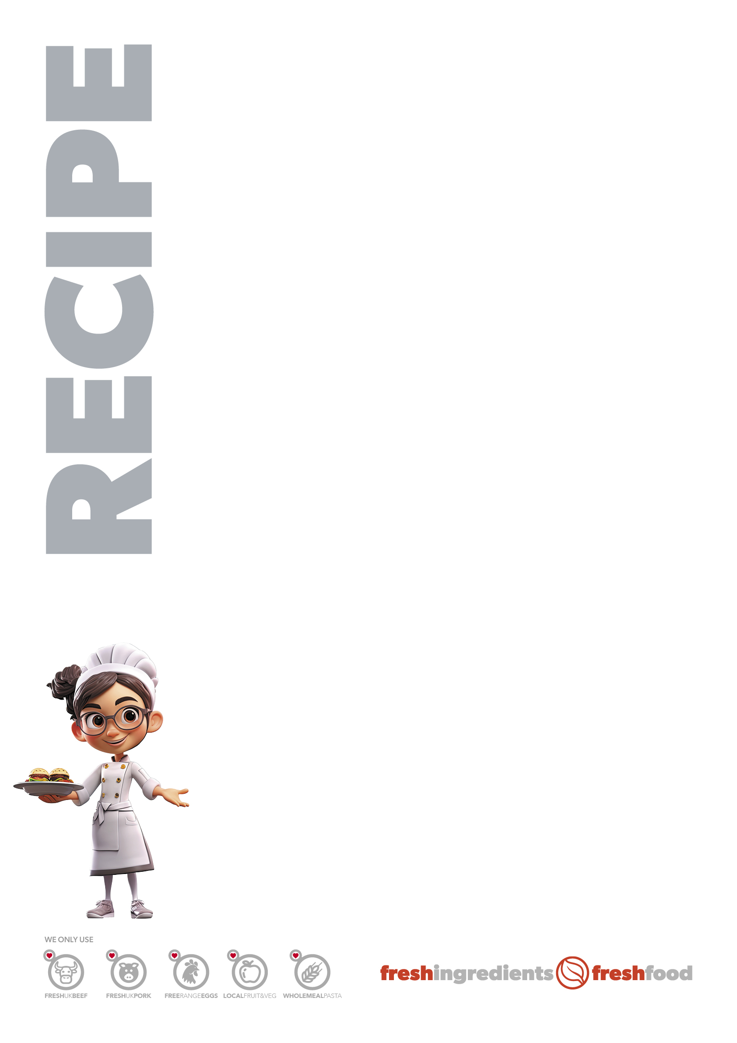
APPLE TART (1 TIN WILL MAKE 32 PORTIONS)
INGREDIENTS
• Puff pastry sheet
• Brown sugar
• Melted butter
• Tinned apples
METHOD
• In a lined long tin sprinkle brown sugar, place thawed pastry sheet on top.
• Fold edges 1cm in using a bit of water.
• Fork base to stop rising too much.
• Part bake.
• Drain and fully dry apples, slice into smaller pieces.
• Put on cooked pastry, sprinkle brown sugar, drizzle with melted butter
and bake.

